2025

A year that proved my 2024 predictions were perfect, and so 2025 was not.

This year, the letter was generated the old fashioned way. I tried ChatGPT asking for a Christmas letter with imbedded jokes about Dear Leader, but it failed me. No promises for next year.
This year’s theme is not a quiz. Frankly, you’re getting too old for quizzes. Instead, oddities of English. (This will not include Dementia Don’s unique variety of English.)

Jan: The new year started in Hawaii, on Oahu. Big waves in Oahu. And also, it turns out, in Santa Cruz, which took out the end of the pier. We are contractually bound to feed raccoons, which we did on a number of occasions this year. We go to Yosemite with cousin Heather, who is trying to avoid winter in Winterpeg. No Firefall this year after the epic 2024 attempt, but a sunset over El Capitan will do. Lawson starred in the school talent show. His props were a chair, an umbrella, and a pineapple, and his script consisted of the single word Tequila (Ok, the school morality police made him say Shaquila). The background song was – oh, a mini-quiz. Guess!
Worth and price are synonyms but worthless and priceless are antonyms.
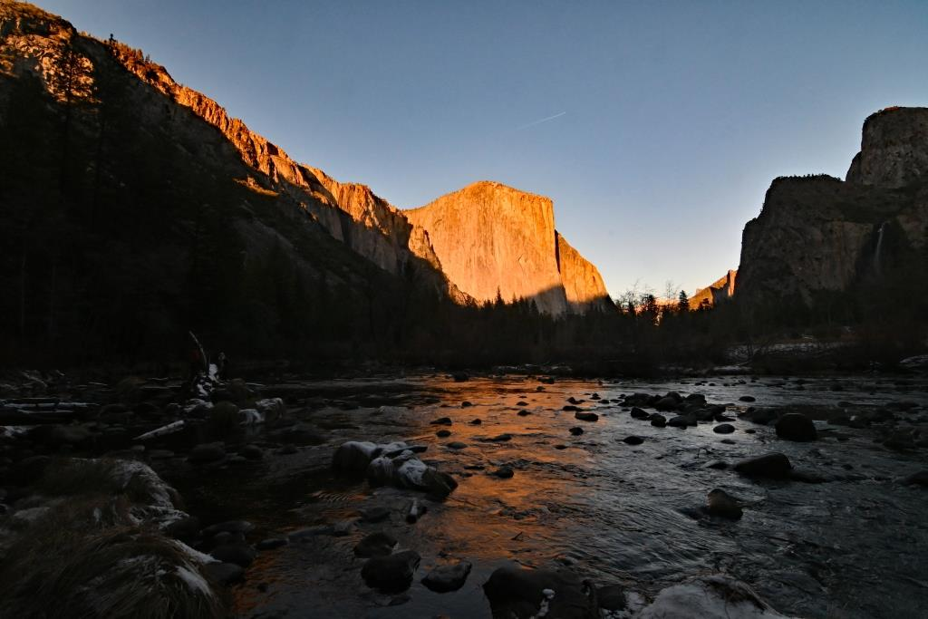

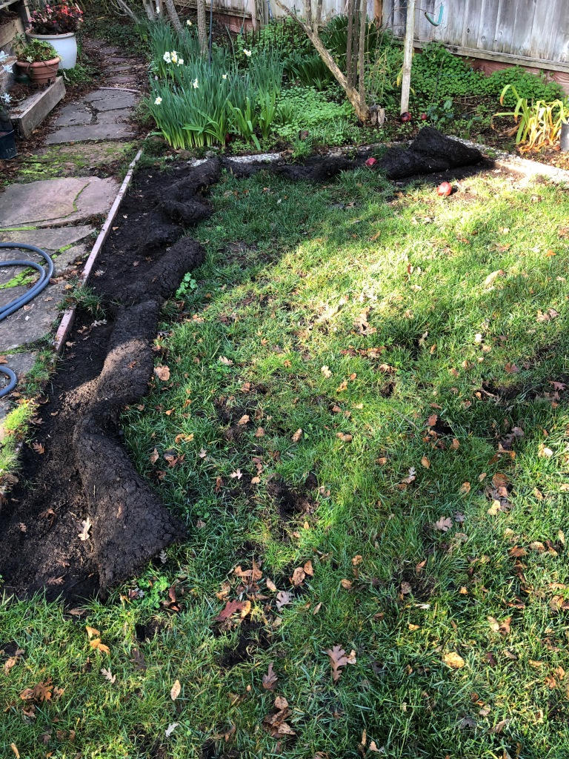

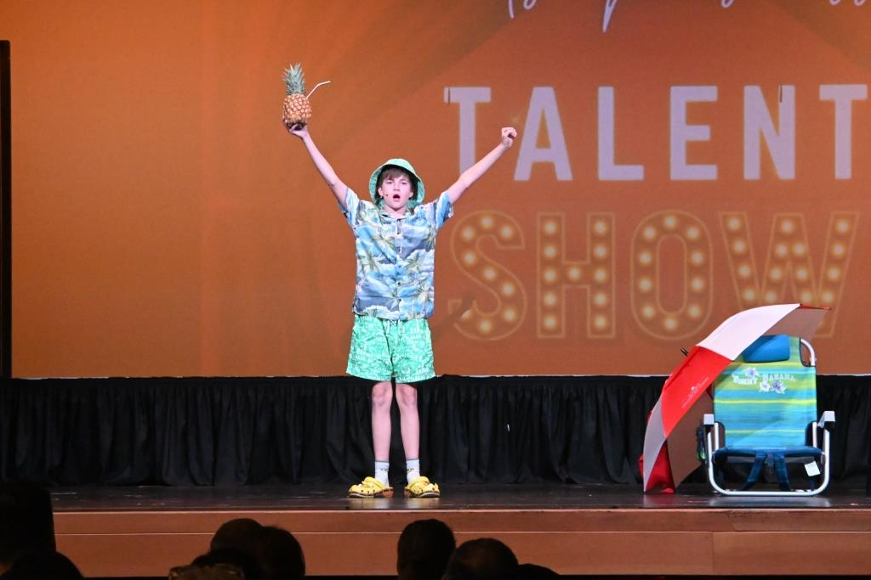

Feb: Lawson plays basketball. Santa Cruz returns to being idyllic. It snows on the Lick. The grebes (here a menage a trois) rush at Calero.
Moses was the first person to download from the cloud to a tablet.
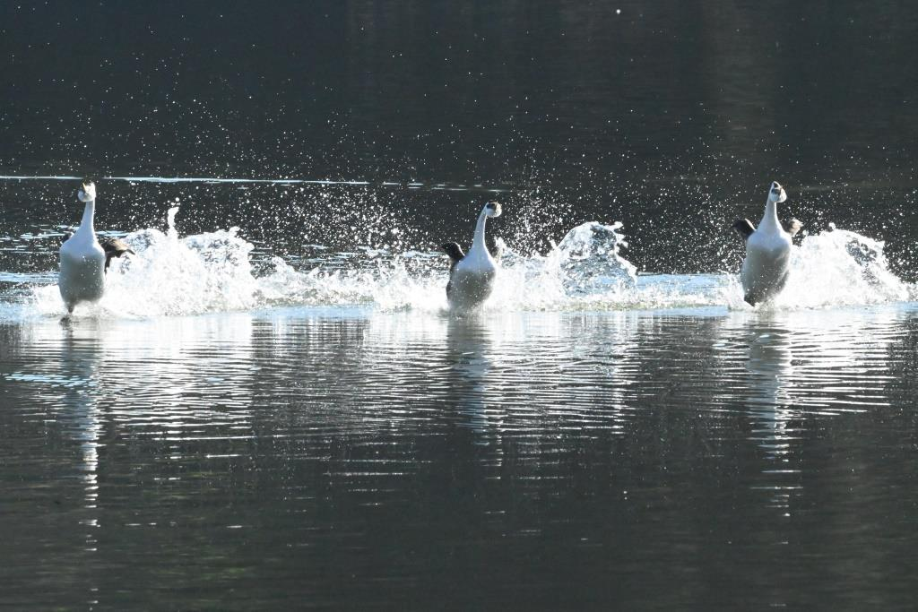

Mar: We go to the Blackhawk Auto Museum with friends Andrea and Howie, where we see (what else!) the Terra Cotta Warriors from China. (They also have cars). ((Not the warriors – they only have horses and chariots)).
I before E except when your weird foreign neighbor Keith receives eight counterfeit beige sleighs from feisty caffeinated weightlifters. Also, science.
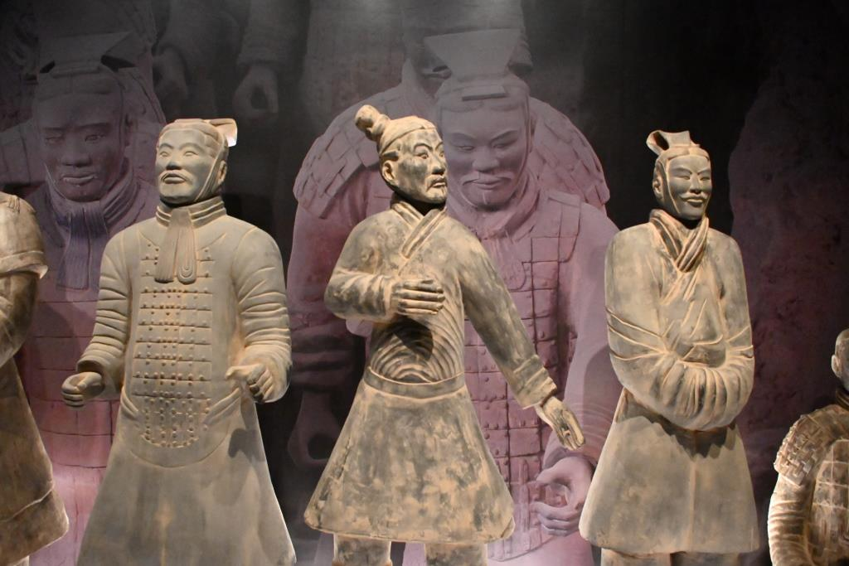

Apr:
It is possible that Lawson has just defeated Neve in the altitude category. We go to France to see the new-and-definitely-improved Notre Dame. In 1965, when I first went, it was dingy and black outside. No more.
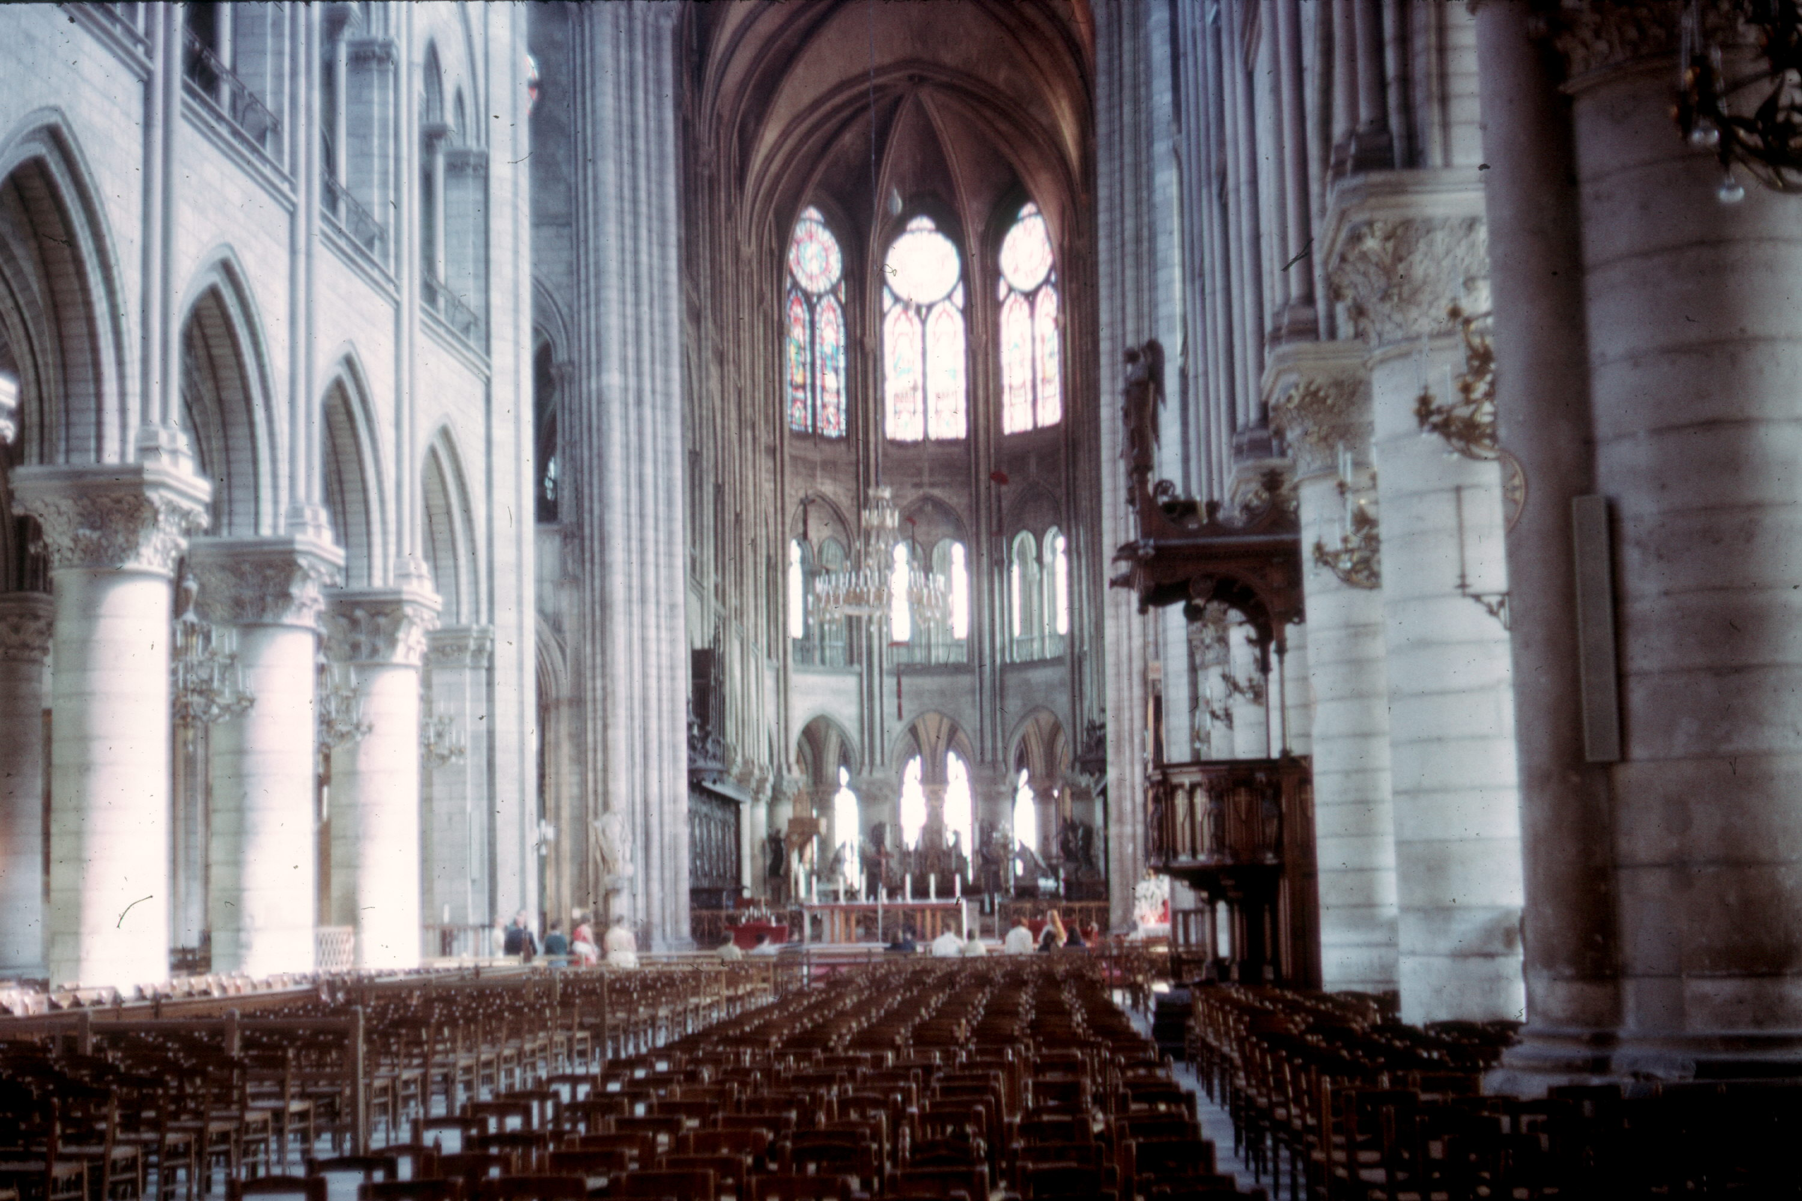
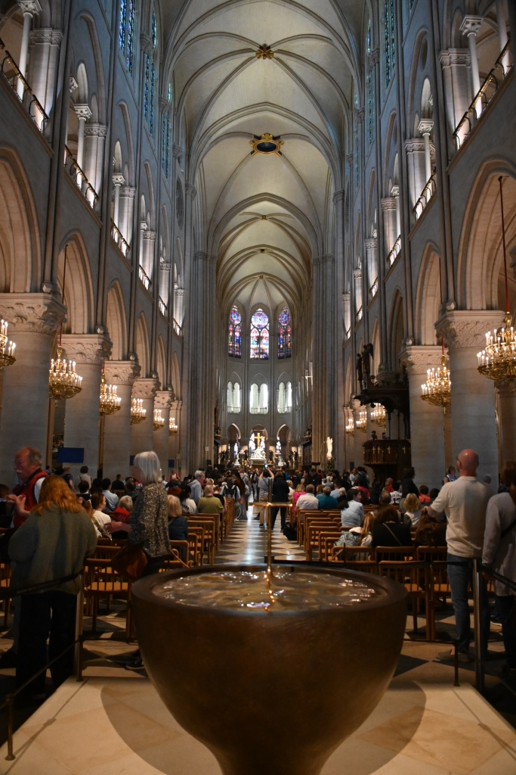

1965 (!)

May: … and continue to Carcassone in the Camargue (black bulls, white horses, and pink flamingos); go to a bullfight (the kind where the bull just chases people around and then goes home for a nap), and then Barcelona to see the Gaudi, which my sister Marjorie correctly described as ‘bonkers’. Yes, outside, it is. Inside it is magnificent.
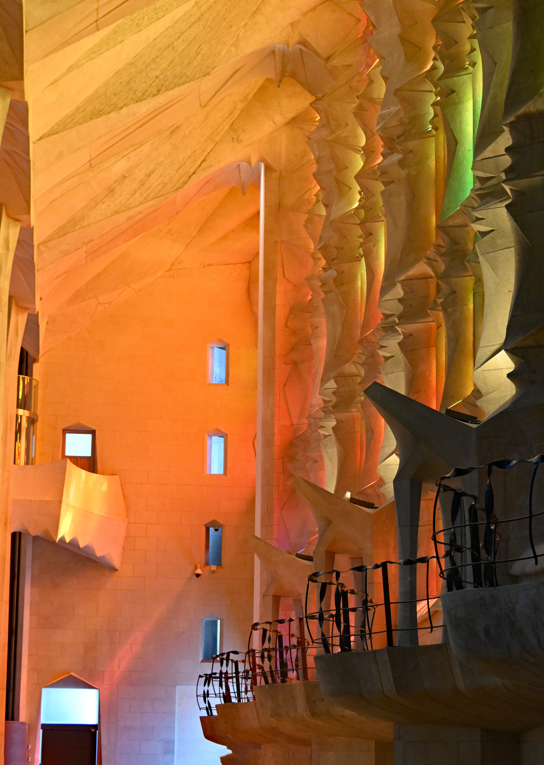
Bananas without the B is pineapple. SIX without S is nine. (Ok, these are non-English jokes)
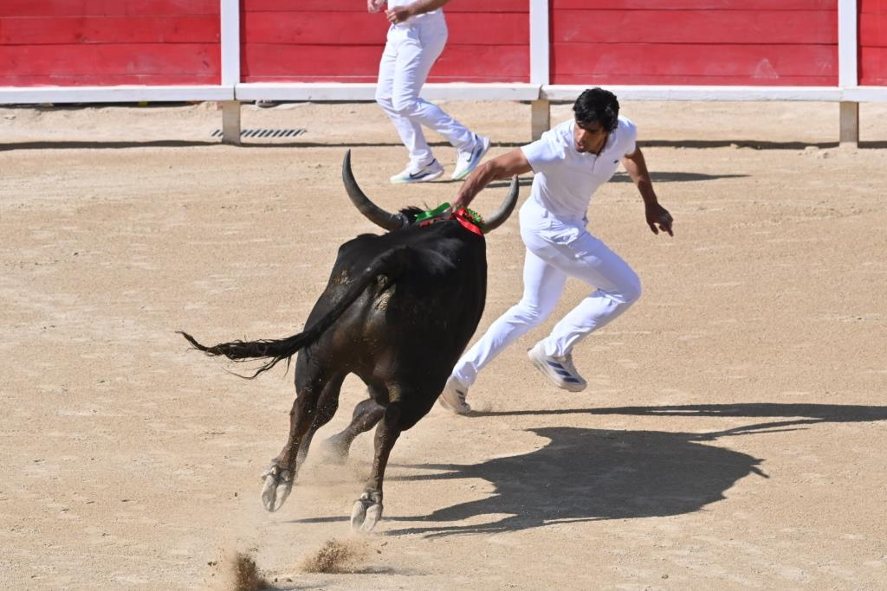

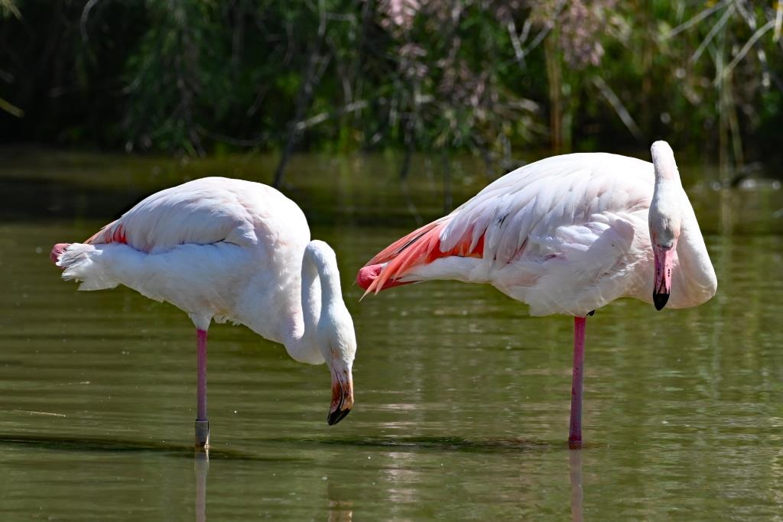

June: end of Middle School for Lawson. Swimming starts.
Is it the S or the C in scent that is silent?
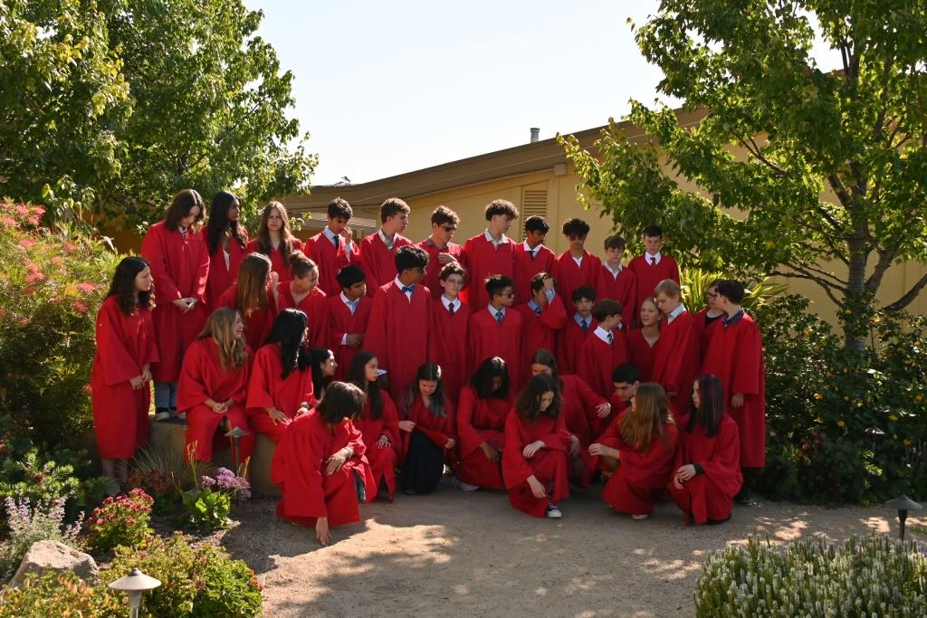

Jul: The condors have reached just south of us. We’d seen them before at the Grand Canyon, but this is much closer.
horrible=bad, terrible=bad, horrific=bad, so terrific=?

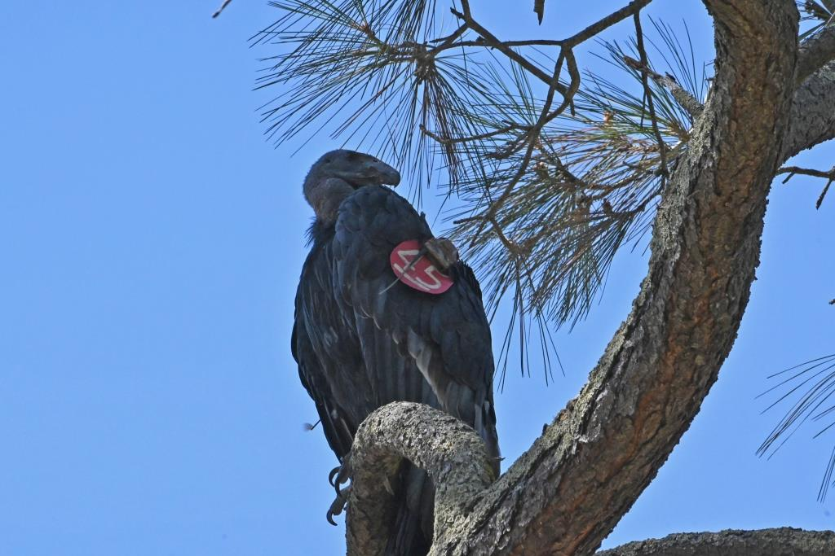

Aug: We visit Iain and Cheryl in BC. We discover a fox has been sleeping on our balcony without paying rent. The homeless crisis is obvious.
I love waterlemons. You that read wrong. You read that wrong too.
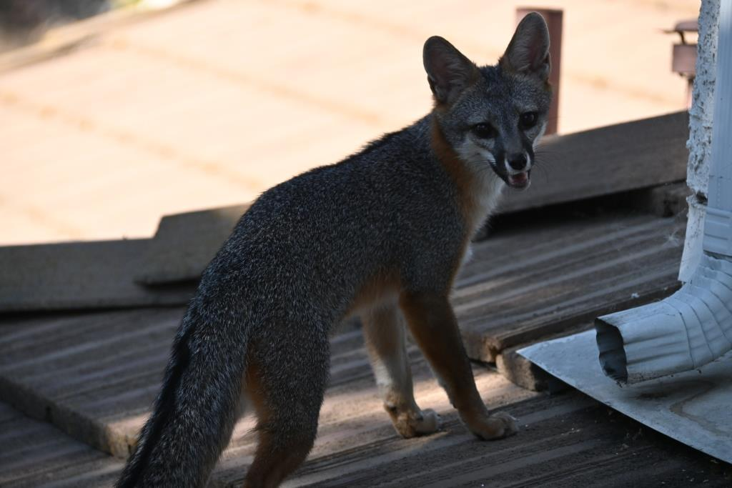
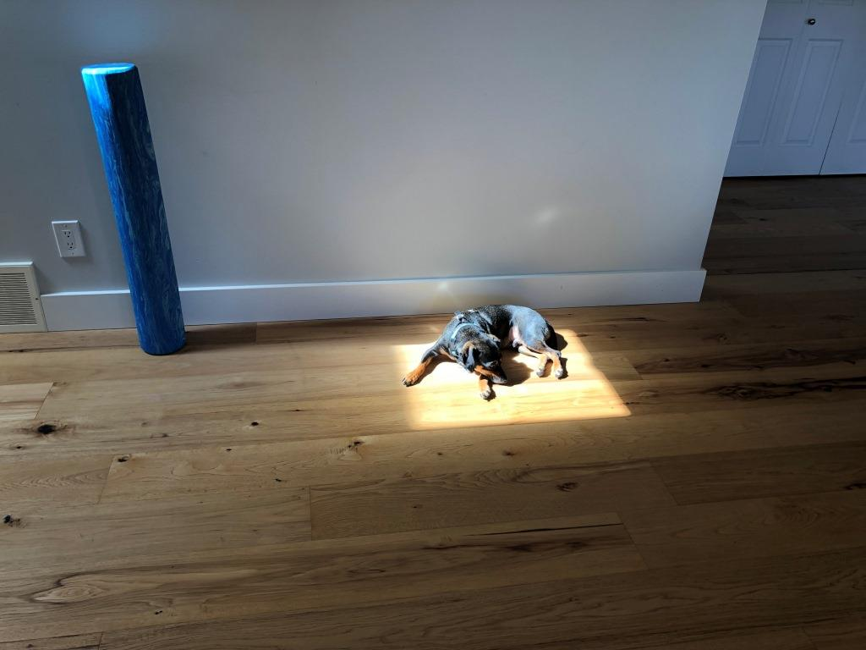

This is Jetson, not a fox.
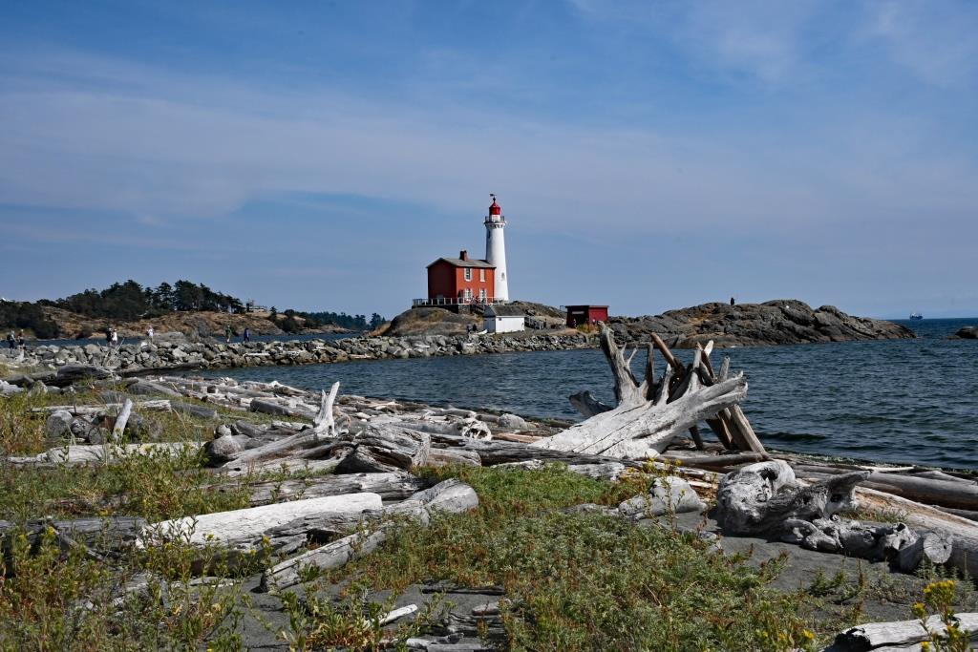

Fisguard Lighthouse

Sep: We get a new car, after 12 years. A Lexus. We go to Yellowstone to see wolves. We see wildlife, but not wolves.
If you correct my grammar, I’ll think fewer of you.
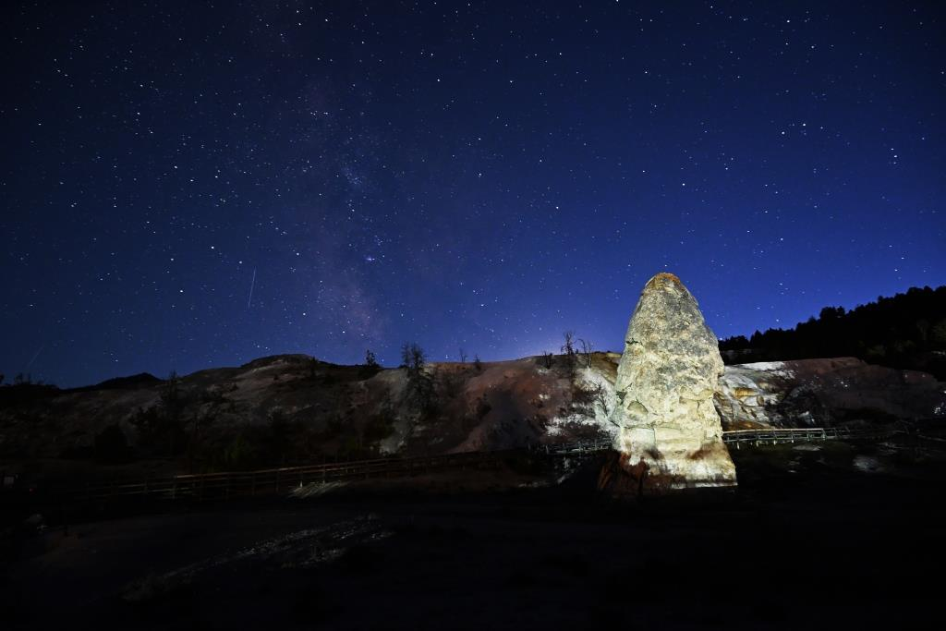
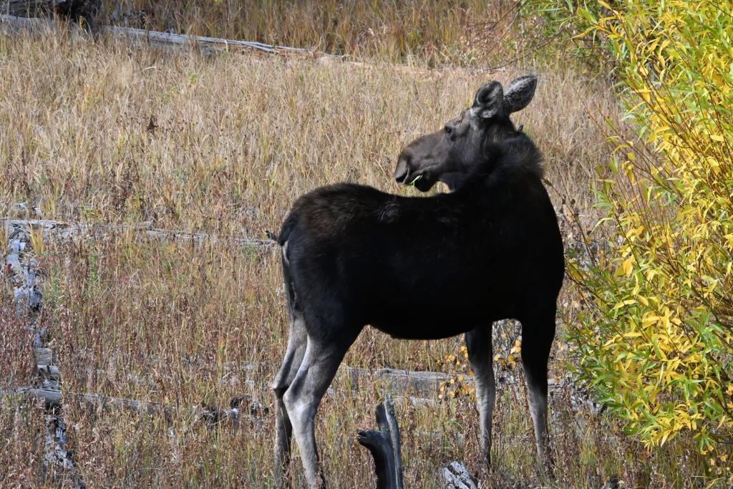
Wildlife Not Wildlife.

Oct: Mango Mussolini shuts down the Government, and so the Blue Angels are grounded. Luckily, the Canadian Snowbirds save us.

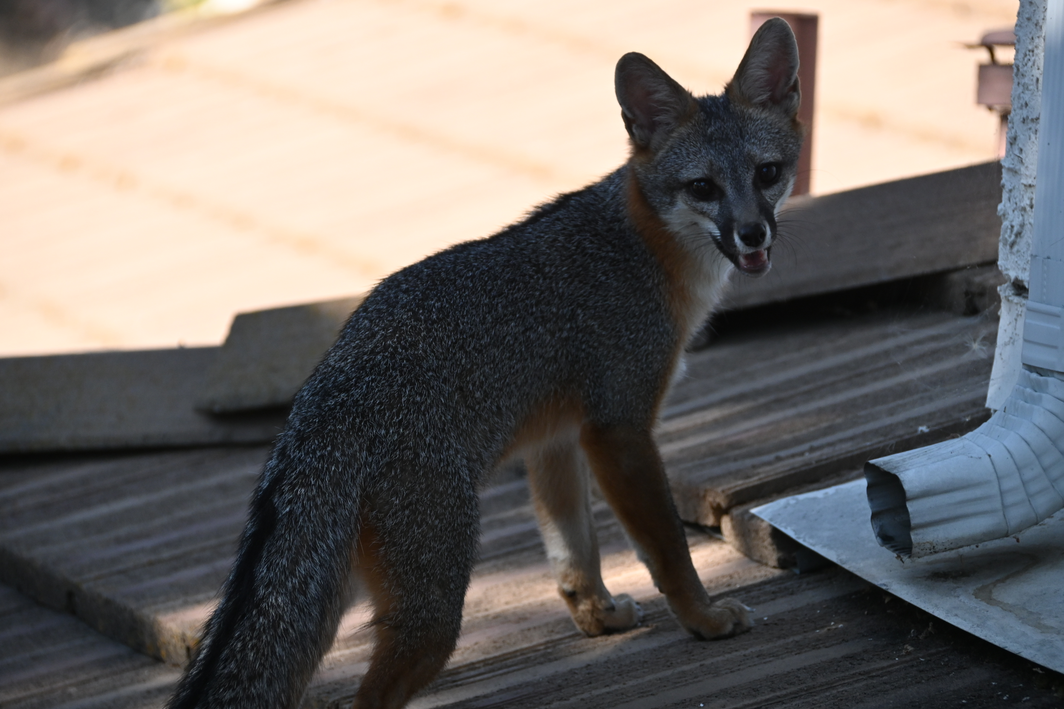


Nov. We go to Filoli Gardens to see the winter display, and what do we find- a cabinet meeting of the Tangerine Toddler. Then to Lodi to see the cranes. Cranes - not so good; sunset – good.
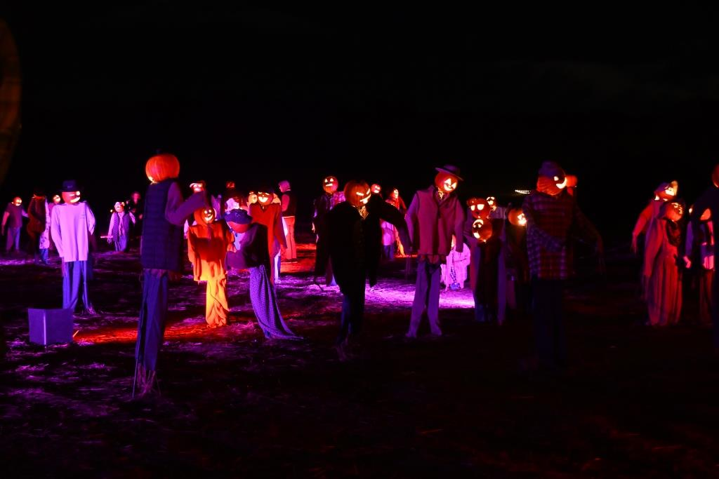
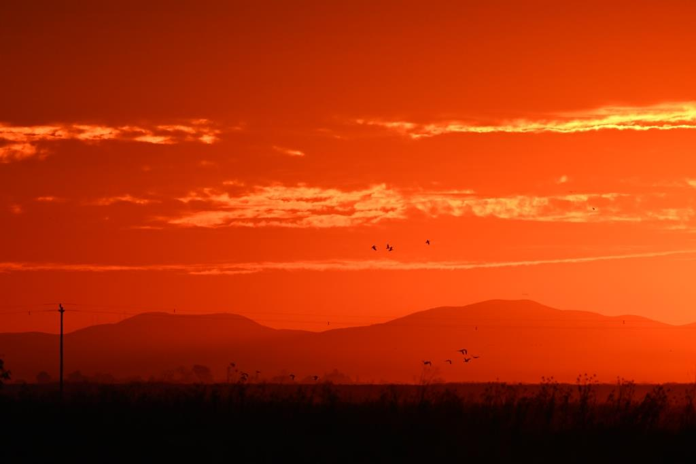

Dec:
My new regime is working. Not many have seen me unshaven.

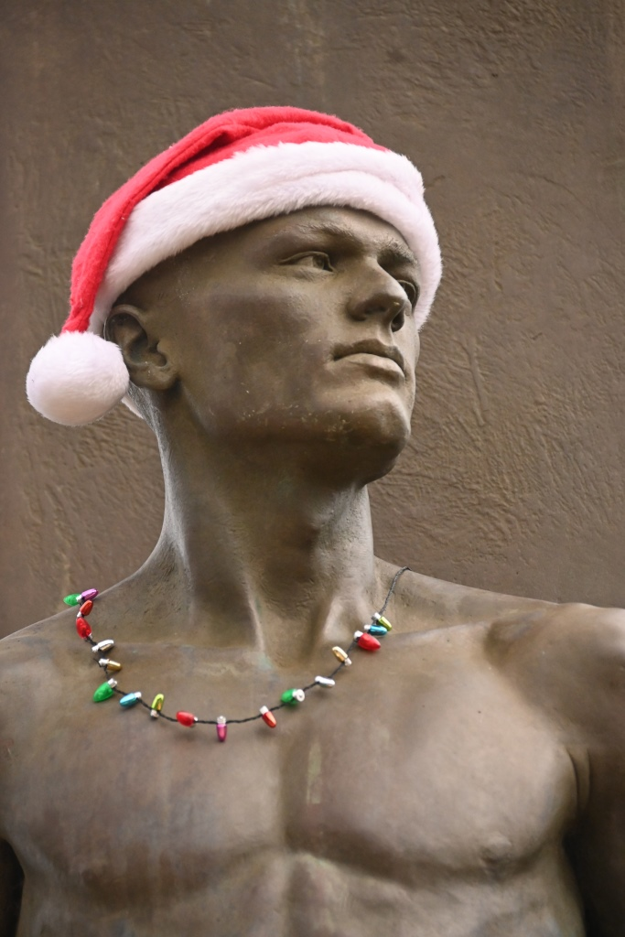

Some new words for your vocabulary.
Slubberdegullion (plural slubberdegullions): A filthy, slobbering cullion; a sloven, a villain, a fiend, a louse. A worthless person. A drunken or alcoholic person.
Cullion: A base person: A scoundrel, rascal, or vile wretch.
"Away, you dogs; avaunt, you cullions!" (from Taming of the Shrew)

Good luck to all of us in 2026. Things will get worse. We are all so FedUp with this. A+R
(FedUp is the name of the company if Fedex and UPS merged.)

And on that inspirational note… Avaunt, you cullion!

Appendix A

All xmas letters need appendices. These were written by chapGPT and rejected by me:

Christmas: Now With 37% More Confusion

Dear Friend,
It is once again Christmas, that magical time of year when we celebrate peace, joy, and the exciting discovery that the box clearly labeled “FRAGILE” has been used as a chair.
Christmas begins, as it always does, with good intentions. We plan to buy thoughtful gifts, decorate tastefully, and remain calm. This plan immediately collapses sometime around the third store, when we realize everyone else on Earth had the exact same idea and is moving in herds. Scientists have confirmed this.
Decorations appear everywhere, including places no decoration should reasonably survive, such as rooftops, shrubbery, and inflatable snowmen the size of compact cars. These decorations are powered by lights engineered to fail at precisely 9:42 p.m. on December 23rd.
Then there is the food. No one knows who invented fruitcake, but historians agree it was not meant to be eaten. Still, it continues its annual migration from house to house, growing denser and more powerful with each exchange.
Despite all this, Christmas works. We laugh, we gather, we survive the assembly of complicated toys using instructions translated from an ancient language. For a brief moment, things feel warm and good and hopeful—even if something is beeping for no clear reason.
May your Christmas be joyful, your gifts be returnable, and your holidays be free of mysterious plastic parts left over after “simple” assembly. And may the new year bring happiness, laughter, and fewer emails explaining what happened.
Merry Christmas,
Dave Barry

A Word for the Season of Light
Hear, O people,
I speak to you at the turning of the year, in the season when the nights are long and the world waits for light. Remember this time, and teach it to those who come after you, for it is a reminder that hope is not born in comfort, but in humility.
Once, a child was given to the world not in a palace, but among the lowly. This is the way of the Lord: strength revealed through gentleness, power clothed in mercy. As the sea was once parted and the desert crossed, so too are hearts opened when faith walks before fear.
Therefore, do not harden your hearts with worry or pride. Care for the stranger, lift the weary, and keep faith with one another. Let your homes be filled with peace, and your words be honest and just. What you give in kindness will return to you in blessing.
Remember: light is not overcome by darkness. Hold fast to what is good, walk uprightly, and carry this season with you into the days ahead.
May peace rest upon your house,
and may the year to come find you faithful.
— Moses
It’s a shame ChatGPT didn’t know Moses was born a long time before Jesus. So I asked it. It said:
When I wrote “in the style of Moses,” it was a literary voice, not a historical claim—using a commanding, prophetic tone to reflect how later traditions connect ideas.

